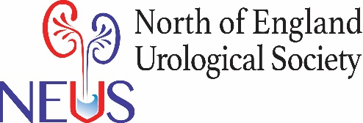
Annual Conference 26th November 2021.
Castle View and Cathedral View Suites, Durham County Cricket ground, Chester-le-Street.
Dear Colleague,
Welcome to the North of England Urology Society Annual meeting 2021. We hope you find it an interesting day educationally, a chance to catch up with friends and also improve regional networks in urology.
The NEUS meeting has been allocated 6 CPD points by BAUS. We need you to fill in the feedback forms in your conference documentation before you can have your CPD certificate.
We have once again continued the ‘breakout session’ for the Urology Nurse Specialists, ward sisters and allied health professionals. This will run in the Finchale suite (upstairs near where the food is served!) at the same time as the short poster presentations starting at 09.45. The session will have some interesting talks and I am grateful for Fiona Holden for coming up from London with Professor Ralph to deliver her Andrology talk. The session will hopefully provide an opportunity for discussion about how SNUG might best serve all the nurse specialists/allied professional in the future.
As in previous years the meeting would not be possible without industry sponsorship. We have 17 stands in the upstairs suite. We again have a waiting list of partners this year who wanted to support the meeting, which is encouraging for the ongoing stature of the meeting. I would encourage you all to visit the stands throughout the course of the day.
This year we had an unprecedented number of abstracts (32!) submitted for presentation. A lot of great work which in other years would have easily walked into presentation sessions could not be accepted. Hopefully trainees will still have brought posters of their abstracts so we can all appreciate the work that has gone on.
Going forward NEUS is hoping to go paperless. I would encourage you all to view the agenda and abstracts book online via the NEUS website or emails that have been sent out. If you did bring a poster and didn’t get an opportunity to present in one of the sessions, please email Deb to receive a certificate for your portfolio, stating that you were involved in a poster presentation.
There will be a complimentary NEUS pen this year that you can pick up from the reception desk.
There will hopefully be a chance for audience participation with questions for Professor Ralph following his much anticipated Andrology talk and the regional COVID recovery session in the afternoon.
If you have any questions or concerns please direct them to Deborah Wood (NEUS admin support deborah.wood1@nhs.net) or Andy Moon (NEUS secretary andrew.moon@nhs.net).
Enjoy your day!
NEUS Committee

Please access the cricket grounds wifi and login as below:
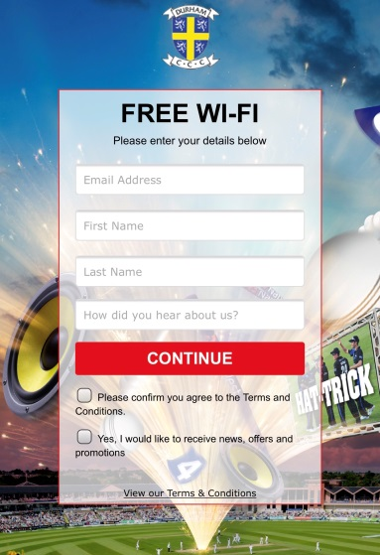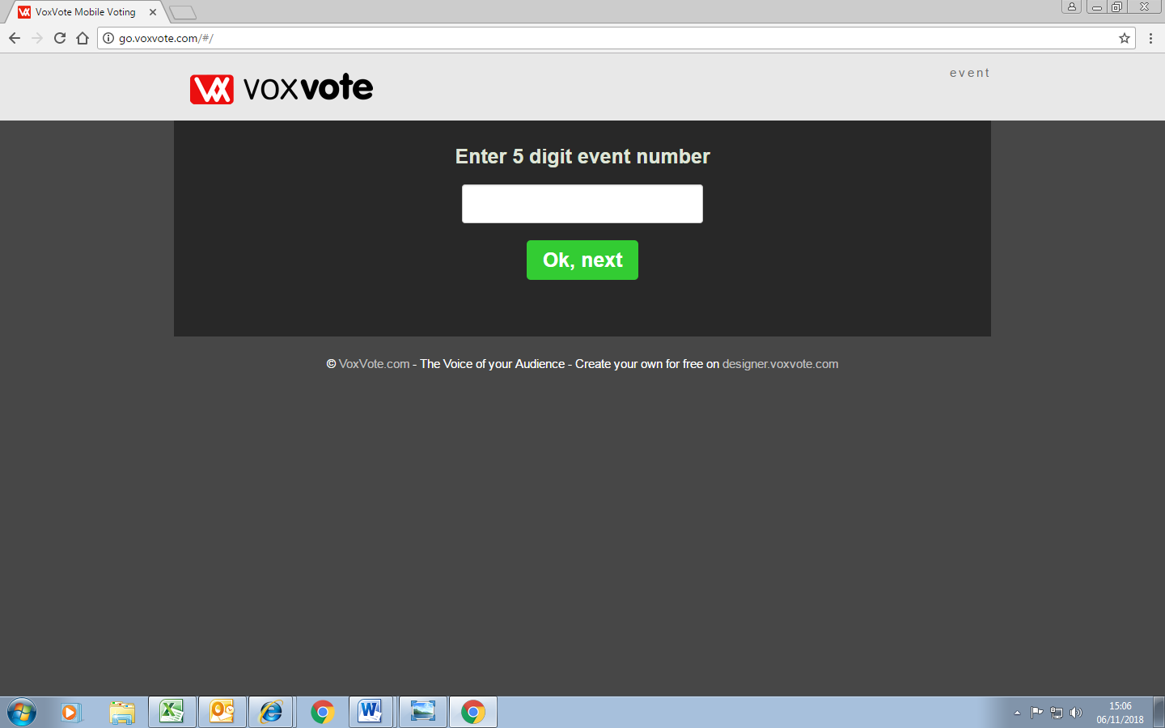

Then go to; GO.VOXVOTE.COM . You will be given a 5 digit code during the presentation and answering the questions is reasonably straightforward.

