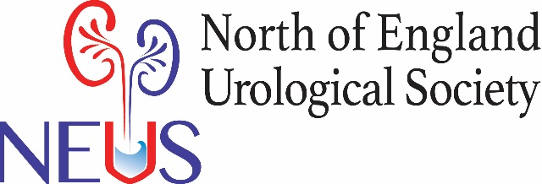

NEUS 2022 Presenter information
NEUS 11th November 2022, Durham County Cricket Ground, Chester le Street
PODIUM PRESENTATIONS (11:30-12:45)
- Professor Pickard plate

SHORT POSTER PRESENTATIONS (15:30– 16:45)

- For this session you need to have brought a poster and put it up at the beginning of NEUS. (see poster instructions below)
- There will be 4 MINS for PRESENTATION and then 2-3 MINS for QUESTIONS.
- Please bring with you on a memory stick a power point presentation of NOT MORE THAN 3 SLIDES representing the salient points from your poster. Alternatively you can show a slide of your poster and zoom into relevant points. If you just display the poster on a power point slide it will be difficult for the audience to see it. Zooming in (unless you have the software) could be tricky so 3 SLIDES is likely to be easier.
- You will be held to time and marks will be awarded for timekeeping.
- The top scoring presentation will be awarded the short poster prize.

Poster information for all delegate bringing posters
- The poster boards are for pins and these will be provided for you to attach your posters.
- Please put them up before the first poster presentation session (10.00).
- Please make your posters to A0 size (841 x 1189 mm) and to be in the PORTRAIT orientation.
- If you have any questions about making your poster please email f.kirkup@nhs.net

