NEUS committee

Mark Johnson Andy Moon Rajan Veeraterapillay Fay Kirkup
(Chair) (Secretary) (Treasurer) (Admin - f.kirkup@nhs.net)
NEUS Summer 2022 Newsletter

Dear All
Firstly, a few words from our BAUS Regional Representative – Mr Mark Johnson.
Dear NEUS members

Greetings and I hope that everyone is enjoying the summer. It seems a long time ago now but it was great to see so many people from around the region at the NEUS meeting last November. It was one of the first face to face meeting since Covid restrictions eased and was a very welcome opportunity to catch up with friends across the North East. I would especially like to thank Andy Moon and Debbie Wood for organising the day. There were lots of fantastic contributions to the meeting and it was a real delight to welcome David Ralph to the North East. He is a genuine world leader in surgical andrology and he gave a thoroughly entertaining and informative talk. Hopefully a few of you managed to get to the BAUS Annual meeting in Birmingham this year and again it was a great chance to both gain some CPD and meet up with friends from around the country and indeed further afield. It was also fantastic to see that the North East were well represented at the meeting with significant contributions from a variety of colleagues around the region. Hopefully this will increase our profile nationally both as a place to train and a place to work as a consultant. Don’t forget that registration also allows access to the presentations online if you missed anything of interest and is available through the BAUS website.

With regards to news from BAUS there are few things to mention. I am sure that you are all aware that Jo Cresswell has now taken over as President from Tim O’Brien but you may not be aware that Ian Pearce was recently elected as Vice president. I hope you will join me in wishing Jo every luck during her 2 years at the helm of BAUS. I would also like to thank Tim for all of his hard work on behalf of British Urology and it is a real shame that Covid meant that he didn’t get the chance to showcase his obvious talents in a more public manner during his 2 year tenure.

BAUS is continuing to explore the possibility of developing a smartphone based App and there is a lot of work going on to make sure that it will be fit for purpose if and hopefully when it is commissioned.

The lack of a reliable supply of BCG is a major source of anxiety to our patients and whilst BAUS has played a central role in providing guidance to units it is not a comfortable situation for any of us. BAUS have raised this issue at the highest level within the NHS but I fear that the lack of resilience in the worldwide production of BCG following the closure of the Canadian BCG Connaught production facility in 2012 means that this problem is not going to go away anytime soon.

BAUS are keen to gather information about workforce and assess our own diversity and it would be really helpful if every member could update their online profile on the MyBAUS section of the BAUS website. This only takes a couple of minutes, and the data will be analysed in a GDPR compliant and anonymous manner.

The next BAUS Annual meeting will once again take place in Birmingham from 19th to 21st June 2023 and please put the date for the next NEUS meeting in your diary (Friday 11th November 2022 at Durham CCC).

I would like to thank our secretary Andy Moon and treasurer Matthew Shaw for all their hard work on behalf of NEUS and I am sure that we will all give a very warm welcome to Fay Kirkup who has joined the NEUS team as administrative support for the committee.

As always if you want to me to bring something to the attention of BAUS council then please don’t hesitate to contact me.

Once again have a good summer everyone and take care!

Mark Johnson; BAUS NE Regional Rep
Email: mark.johnson27@nhs.net
NEUS Annual Meeting 2022

The next NEUS meeting is Friday 11th November and will be held at the Riverside cricket ground, Chester Le Street, Durham. Lets aim for another excellent turnout and meeting. It will be great to see everyone from around the region again.

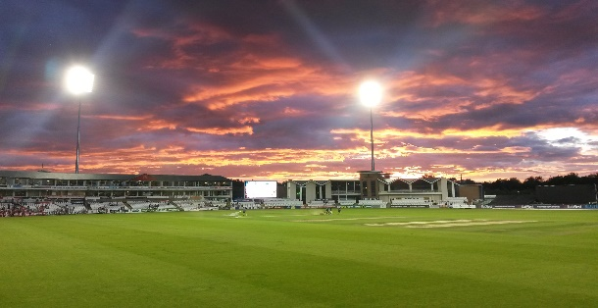

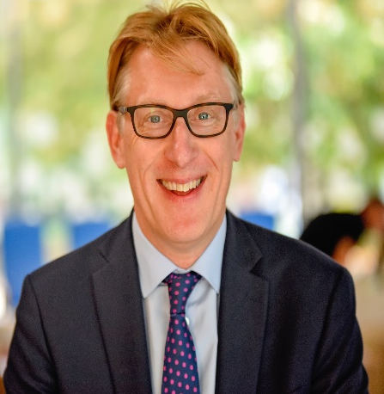

This year our morning keynote session will focus on BPH, day case outlet surgery and in particular Rezum with Mr Richard Hindley. He will also be joined by Dr Margaret Husted a senior lecturer in Psychology who is part of their service and team.

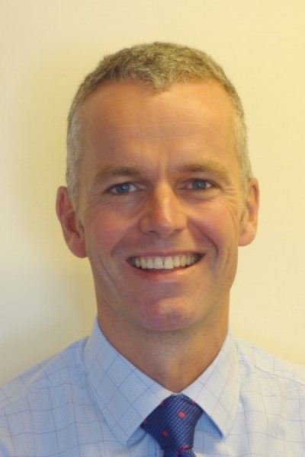

In the afternoon keynote session Mr Kevin Turner will be talking on - “Helping surgeons when it all goes wrong”.

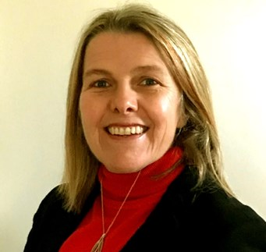

I am also delighted to announce Miss Jo Cresswell will be speaking in her role as the new BAUS president. I understand we will also be joined by Mr Ian Pearce as Vice President of BAUS.

We will once again look forward to the podium and poster presentations highlighting all the fantastic work going on in the region.

NEUS Abstracts

Well done Kamran Haq last year’s NEUS 2021 winner. We look forward to presenting the Professor Rob Pickard Plate to the best paper on the day, so please get working on those projects.

Abstract submission has now opened with deadline for submissions midnight Friday 23rd September.

I am pleased to announce the return of the best ISCP North East trainee portfolio which is awarded at the meeting in November following the annual regional ARCP meeting.

I am also pleased to announce the introduction of the North East Cystoscope award. This will be awarded to the Consultant trainer in the region who has made a significant contribution to training in the region over the past year. More details to follow.


As part of an increasing need to be more sustainable / greener, NEUS 2022 will once again be paperless with the programme of events and abstracts to be available to download from the NEUS website (www.neus.co.uk).

BOOK YOUR STUDY LEAVE NOW!

We are hoping to utilise the NEUS website more so please check it out for updates and news.
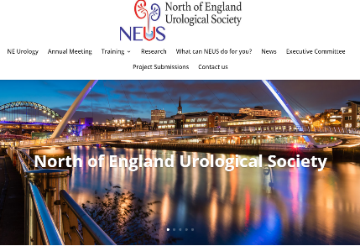


ISCP update- Miss Vicky Lavin
As acting TPD I would like to firstly pass on our collective well wishes to Miss O’Riordan and look forward to her upcoming return.
There are not too many changes this year with regards to ISCP but as we get used to the new curriculum, MCRs have proved a challenge throughout specialty training - we will discuss this more at the planned HENEE workshop on 20th September - this looks to be a promising afternoon where we can answer any queries regarding the curriculum and address ARCP requirements going forwards – please bring your questions in readiness for the event.
We have had excellent recruitment this year and appointed 6 new ST3s and look forward to welcoming them to our fantastic regional training. A big congratulations to those who have CCT’d this year - Tom O’Hare, Angus Luk and Kamran Haq – wishing you all a successful start to your careers.
I would also like to take this opportunity to thank our trainers - you are all brilliant and much appreciated by the trainees and thank you for your continued enthusiasm during difficult times.
Vicky Lavin – acting Urology TPD
SNUG @ NEUS
At this year’s NEUS meeting there will be a dedicated ‘breakout’ session for the Specialist Nurse in Urology Group (SNUG) SNUG hosted by Chris Hall and Pauline Bagnall. Please encourage your nurse specialists to come along. If any of the nurse specialists have got any topics that they would like to present on / cover please contact Andy Moon (Andrew.moon@nhs.net)

NEUS Sport - Cricket
The annual NEUS vs ENT match was held on the 3rd of July at Heaton Cricket ground. There was an excellent turnout from around the region and it was great to see a number of families down supporting.
Well done to the Urology team who won the match !
NEUS Golf Day – We are pleased to announce the return of the NEUS Golf Day this year being held on Sunday October 2nd at Close House. For those who are interested please email campbelltait@nhs.net to confirm your place.
NEUS Sport / Activities – If anyone is interested in arranging any other NEUS activities, please get in touch with ideas or suggestions. It is a great way to catch up and see friends and colleagues from around the region.
Look forward to seeing you all soon!
Best wishes
The NEUS team

