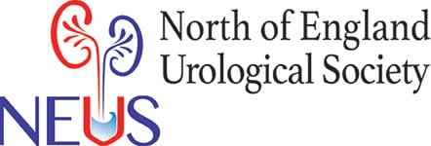
NEUS 2025
Friday 7th November 2025
St James’ Park, Newcastle upon Tyne

Dear NEUS members,

Save the date – NEUS 2025
We would like to warmly invite you all to attend this year’s NEUS meeting on Friday 7th November 2025.

Departing from previous tradition, we will be hosting this year’s meeting at St James’ Park, football stadium of Newcastle United F.C. in Newcastle. We believe this change will offer a better overall experience for attendees, with improved facilities and the opportunity to enjoy social activities afterwards. Stay tuned for the programme of the meeting.

Call for abstracts – submissions now open
We are now also calling for abstract submissions for presentation in NEUS 2025. This regional forum has always been a great opportunity for trainees and allied professionals alike to showcase their hard-work, and gain recognition for it.

The standard and variety of previous presentations has been excellent and we are looking forward to another excellent meeting. There will be podium and shorter poster presentations, similar to previous years. There will be prizes awarded for the best poster presentation and best podium presentation. In addition, the best podium presentation will be submitted to BAUS annual meeting for the best regional presentation award.

We would welcome abstracts from medical students, foundation doctors, trainees, urology nurse specialists, urology ward sisters or allied professionals. Do encourage all to get involved and come along on the day.

All abstracts submitted MUST use the Abstract Submission Form (attached) or they will not be considered for selection. Please note that there is also a strict word limit of 250 words. Please email your abstract form to Fay, the NEUS admin support (F.Kirkup@nhs.net). The abstract submission form can also be downloaded from the NEUS website http://www.neus.org.uk/neus-downloads/

DEADLINE FOR ABSTRACT SUBMISSION IS MIDNIGHT Friday 5th SEPTEMBER 2025.

Abstracts will be anonymised and scored, with a decision on accepted abstracts by Friday 3rd October. This should give plenty of time to prepare for posters and presentations.

We look forward to receiving your abstracts and seeing many of you in Newcastle for what promises to be another engaging and enjoyable NEUS meeting.

Best Regards,
Angus – on behalf of NEUS team

Mr Angus Luk
Consultant Urological Surgeon and Honorary Secretary of NEUS

